How to amend MRB (Multi-Room Bookings)?
MRBs made by XML clients and WebBeds Admin users
There are no changes in the functionalities for Multi Room Bookings (MRBs) made by XML clients and WebBeds Admin users. This means that every room booked in a MRB made by XML clients and WebBeds Admin users will have it’s own booking reference and will be handled on a per room basis – similar to Individual Room bookings.

In addition, both Amend Booking and Amend Offline booking functionalities are available for these types of MRBs. These applies to all possible amendments for a DOTW Booking.

MRBs made by POS Clients with a Direct Contract, DMC and Channel Manager supplier
For MRBs made by POS clients, with either a DC, DMC or Channel Manager supplier, the amendments that can be done either applies to all rooms in the booking (like Maker) or can be changed on a per room basis. Further, it can only be done via Amend Offline – wherein coordination with the hotel/supplier should be done first. As a guide:

DATE AMENDMENTS

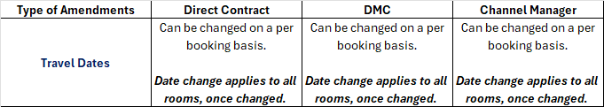
For any Date Amendments done for MRBs made by POS clients with a DC, DMC or CM supplier, the date change applies to all rooms in the booking. This means that, if only one room in the booking would want to change the dates – and the rest of the rooms in the booking wants to keep the original dates, this is not possible as any date change will apply to all rooms in the booking.

In addition, only the first room would allow the user to adjust the dates, in case of date amendment that applies to all rooms.
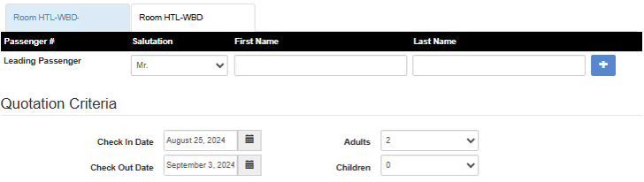

For any other rooms in the MRB, the date amendments for check-in and check-out date boxes are deactivated.
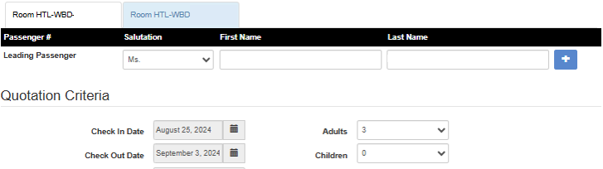

ALL OTHER AMENDMENTS
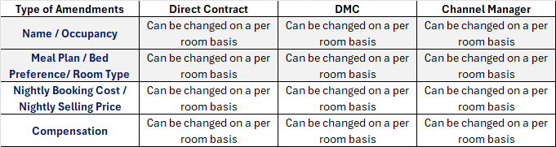

For all other amendments in the MRBs made by POS clients with a DC, DMC or CM supplier, these can all be changed on a per room basis without affecting the other rooms in the booking.

MRBs made by POS Clients with a Dynamic, Third-Party or Intercompany supplier

NAME AMENDMENTS
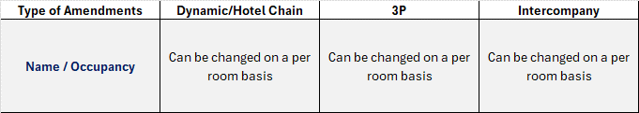

For Name Amendments in MRBs made by POS clients with a Dynamic, 3P or Intercompany supplier, these can be changed on a per room basis, without affecting the other rooms in the booking.

ALL OTHER AMENDMENTS

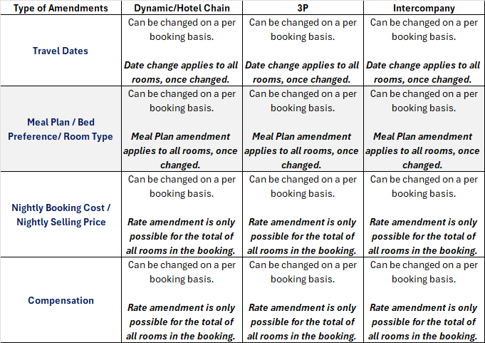

For all other amendments in the booking, these can only be changed on a per booking basis. This means that any changes done for one room will apply and affect all other rooms.

In terms of the nightly booking cost, selling price and compensation, these amounts would show as the total of all rooms in the booking.

